SAFETY DATA SHEET

SECTION 1. PRODUCT AND COMPANY IDENTIFICATION

MANUFACTURER: TRANSENE COMPANY, INC.

ADDRESS: DANVERS INDUSTRIAL PARK

10 ELECTRONICS AVENUE DANVERS, MA 01923

TEL: (978) 777-7860 FAX: (978)-739-5640

WWW.TRANSENE.COM

EMERGENCY NO. 1-800-424-9300 CHEMTREC

MATERIAL NAME: GALLIUM PHOSPHIDE ETCHANT GaP
REVISED: April 2016

CHEMICAL FAMILY: Alkaline Potassium Ferricyanide

SYNONYMS: Mixture

Product Number: 060-0012000

SECTION 2. HEALTH HAZARD INFORMATION

GHS Classifications

H290 Corrosive to Metals: Category 1
H302 Acute toxicity Oral : Category 4
H315 Skin corrosion / Skin irritation : Category 2
H319 Serious eye damage / Eye irritation : Category 2A

Pictograms or Hazard symbols
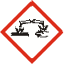Warning: May be corrosive to metals

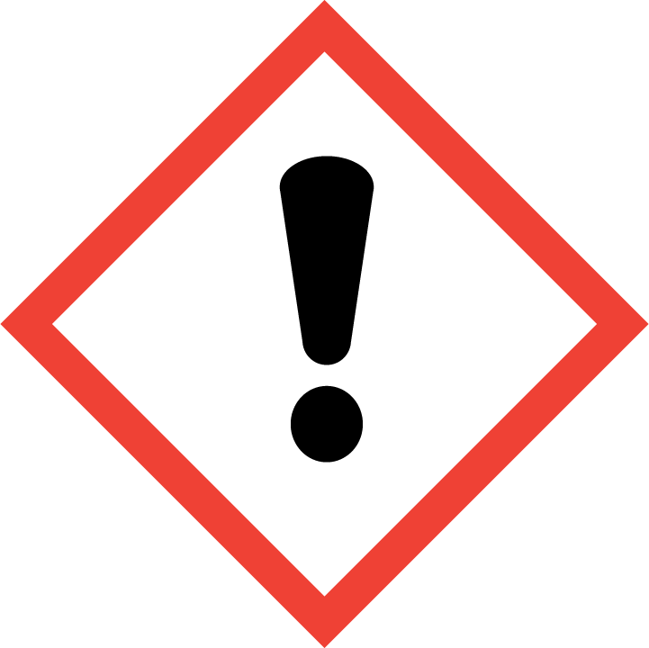Warning: Harmful if swallowed or in contact with skin. Causes skin irritation. Causes serious eye irritation.

Precautionary Statements
P234 Keep only in original container.
P264 Wash thoroughly after handling.
P270 Do not eat, drink, or smoke when using this product.
P280 Wear protective gloves, clothing, and eye and face protection.
P301 + P312 If swallowed, call a physician if you feel unwell.
P302 + P352 If on skin, wash with plenty of water. Remove contact lenses if present and easy to do so. Continue rinsing.
P305 + P351 + P338 If in eyes, rinse cautiously with water for several minutes.
P330 Rinse mouth.
P332 + P313 If skin irritation occurs, get medical advice/attention.
P337 + P313 If eye irritation persists, get medical advice/attention.
P362 + P364 Take off contaminated clothing and wash it before reuse.
P390 Absorb spillage to prevent material damage.
P406 Store in corrosive resistant container.
P501 Dispose of contents/container in accordance with local/regional/national/international regulations.

SECTION 3.COMPOSITION/INFORMATION ON INGREDIENTS

Material  Potassium Hexacyanoferrate CAS# 13746-66-2  Potassium Hydroxide CAS# 1310-58-3  Water CAS# 7732-18-5  Total | Wt %  30-40  1-5  55-69  100

SECTION 4. FIRST AID MEASURES

EFFECTS OF OVEREXPOSURE
FIRST AID:
Eye Contact: Corrosive to naked eye; in case of contact flush eyes well for 15 minutes, lifting the lower and upper eyelids occasionally. May cause permanent eye damage or blindness. Seek medical attention.
Skin Contact: Corrosive to exposed skin. Flush skin well with water for 15 minutes, wash with soap and water. Remove affected clothing.
Inhalation: If inhaled, remove to fresh air. If not breathing give artificial respiration. Seek medical attention. Inhalation of vapors may cause coughing, choking, inflammation of the nose, throat, and upper respiratory tract. In severe cases, may pulmonary edema, circulatory failure, and death.
Ingestion: Will cause burns to the mouth and damage to the digestive tract. Causes gastrointestinal burns and perforation of the digestive tract. Get Medical Attention immediately. Induce vomiting with soap solution. Do not give vinegar.
SECTION 5. FIRE FIGHTING MEASURES

Flash Point and Method non-flammable | Autoignition Temp.  NA | Flammability Limits In Air | LOWER  NA | UPPER  NA

Extinguishing media: Water spray. Foam or water fog.
Special fire fighting procedures: Wear chemically retardant gear and NIOSH approved self-contained breathing apparatus. Thermal decomposition produces irritating and toxic fumes. Do not allow to come in contact with acids.
Toxic gases released: Contact with acids may release poisonous hydrogen cyanide gas.

SECTION 6. ACCIDENTAL RELEASE MEASURES

SPILLS, LEAKS: Ventilate area of leak or spill. Stop leak if possible to do so without risk. Clean-up personnel should wear protective clothing and NIOSH approved respirator. Dike and cover the contaminated areas with absorbent, non-combustible material such as earth, sand, or vermiculite. Decontaminate area with sodium or calcium hypochlorite. Do not use combustibles. Do not flush to sewer or waterways.

SECTION 7. HANDLING AND STORAGE

Wash thoroughly after handling. Remove contaminated clothing and wash before re-use. Do not breathe mist or vapor. Do not expose eyes, skin, or clothing. Keep container closed tightly. Avoid contact with open flame and acids. Do not use with metal tools or items. Use with adequate ventilation or respiratory protection. Do not store near acids or in direct sunlight. Store in a cool, dry, well-ventilated area away from incompatible substances. Residue in empty containers may still be hazardous.

SECTION 8. EXPOSURE CONTROL/PERSONAL PROTECTION

Respiratory protection: Wear NIOSH/MESA approved full or half face piece (with goggles) respiratory protective equipment to avoid exposure to vapors above 0.1ppm. A respiratory protection program complying with requirements of 29CFR 1910.134 is recommended.
Ventilation: Where adequate ventilation is not available, use NIOSH approved vapor respirator with dust, fume and mist filters. Local ventilation through fume hoods or laminar flow stations is also preferred. Keep fumes away from strong bases.
Protective gloves: Skin contact should be minimized through use of rubber gloves.
Other protective equipment: Steel tipped shoes/eye wash station/chemical safety chemical retardant clothing. Eye protection: Safety goggles / face shield

SECTION 9. PHYSICAL AND CHEMICAL PROPERTIES

Form : Liquid
Appearance : Amber
Odor : Mild to none
pH : 13-14
Melting point: 0 ºC
Boiling point/Boiling range : 100 ºC
Flash point : Non-flammable.
Ignition point : Will not ignite.
Danger of explosion: Product is not explosive
Decomposition temperature: Not available
Vapor density (Air = 1) : No information
Volatiles, %: 55-69
Vapor pressure at 15º C, mm Hg: Not available
Specific gravity : 1.14-1.16
Solubility in / Miscibility: Completely miscible in water
Evap. Rate (Water = 1): No information found

SECTION 10. STABILITY AND REACTIVITY

Stability |  | Stable X Conditions to avoid: Excess heat , sunlight, confined spaces  Unstable
Incompatible with:
Most common metals, acids.
Hazardous decomposition products: Hydrogen cyanide gas
Hazardous polymerization: | May occur Conditions to avoid: Excess heat, direct sunlight.  Will not occur X

SECTION 11. TOXICOLOGICAL INFORMATION

ACUTE:
Oral rat LD50: 4800 mg/kg
Ingredients investigated as a tumorigen, mutagen, reproductive effector
Carcinogenicity: NTP: No IARC: No Z List: No OSHA reg: No
IARC Category No

OTHER DATA:
Corrosive to skin, eyes, and mucous membranes.

SECTION 12. ECOLOGICAL INFORMATION

Bioaccumulation : When released into the soil, this material is not expected to biodegrade. When released into the soil, this material may leach into groundwater.

Environmental Toxicity: This material is suspected of being harmful to aquatic life.

SECTION 13. DISPOSAL CONSIDERATIONS

DISPOSAL: Dispose of in accordance with all federal state and local regulations. Send waste to an approved waste disposal facility.

SECTION 14. TRANSPORTATION INFORMATION

Class 8
PG III
UN1814
Shipping Name: Potassium Hydroxide Solution

SECTION 15. REGULATORY

Symbol: C, Corrosive
R-Phrase: 35, causes severe burns
S-Phrases: 23-36/37/39-45 Do not breathe vapor. In case of contact with eyes, rinse immediately with plenty of water and seek medical advice. Wear suitable protective clothing, gloves, and eye/face protection. In case of accident or if you feel unwell, seek medical advice immediately (show the label where possible).

SECTION 16. OTHER INFORMATION

NFPA Codes:
Health: 2
Flammability: 0
Reactivity: 1
R35: Causes severe burns.
Ingredients are TSCA listed.

